Workplace Conduct Policy
Guidance for creating your own policy

This policy template has been created by SoundCheck Aotearoa to help self-employed people create their own policy that addresses sexual harassment (and other conduct matters). This template brings together parts of the SoundCheck Aotearoa template Policy and Code of Conduct, but in a shorter form suitable for a self-employed person, sole trader or small business.
Who should use this template and why?
Any “person conducting a business or undertaking” (also referred to as a PCBU) should have a policy on sexual harassment. Even if you are self-employed and do not have any employees or contractors, but you are collaborating or working with others (e.g. a producer collaborating with artists) then you should still have a policy that sets out your approach to preventing and responding to sexual harassment that will apply to anyone you are working with.
This template is drafted in the first person (‘I’ and ‘me’) for sole traders, but small PCBUs could also use it if they adjusted that language.
You can also use a document such as this to demonstrate to others you work with your commitment to ensuring safer work spaces in the music community in Aotearoa, and to start conversations about how you can work together across the industry to bring about cultural change towards this goal.
What does this policy cover?
In order to provide sole traders or small businesses one document that covers a range of inappropriate workplace behaviours (rather than having a range of policies), this template briefly references bullying and racial harassment. However, the emphasis of this template is on sexual harassment in light of the identified need to address sexual harassment in the music industry in Aotearoa.
How to use this template
We encourage you to take this suggested policy and make it your own – you might use this one as a base, you may want to go further than this policy, and/or put it in the language you use. This is not meant to be a ‘one size fits all’ document for the industry; rather, it is a resource to help anyone in the industry create their own policy.
An important question for all sole traders using this template is to think about who someone can go to if they don’t feel like they can talk to you, (for whatever reason) You should set this out in the Response section. We recommend you take time to think about this and, if you nominate someone, ensure you have agreed the process they will follow if this occurs.
This document includes ‘Guidance notes’ in yellow boxes and [square brackets] to give you more information. You should delete all guidance notes and this first page before using this policy. You can delete yellow guidance boxes by clicking on them and deleting.

Additional guides, resources and posters are available on SoundCheck Aotearoa’s website.

Workplace Conduct Policy
GUIDANCE: This document covers sexual harassment as well as other workplace conduct (such as bullying and discrimination) so that sole traders only need one document not multiple policies and procedures.
It is up to you what you call it – e.g. it could be Workplace Bullying and Harassment Policy, Behaviour and Conduct, Working with me, Kaupapa (if appropriate).
I have prepared this document to communicate to those that I work or collaborate with:
- the standards of behaviour I am committed to upholding and that I expect of others I work with,
- the process I will follow if you have concerns about behaviour in our workplace.
I have created this policy because I am committed to building working relationships and environments in our industry that do not tolerate bullying, harassment, and/or discrimination on the basis of gender, sexuality, ethnicity or any other attribute; and violence.

Who is covered by this policy?
This policy applies to me, [NAME], and any employees, contractors or other workers I have (if applicable). I also provide this document to other people who may not fall in this category but who I work or collaborate with or who may be in the same work space as me, so we have a shared understanding of the matters in this policy.

When and where does this policy apply?
This policy applies whenever and wherever we are working together, or if there is a situation that is related to, or impacts, our work together. In our industry, this can cover a wide variety of places and situations – including:
- at our workplace and/or any space where we may be working – including recording studios, creative/collaborative spaces, offices, venues, festivals, onstage, backstage, clubs, pubs or bars
- in ‘private’ spaces such as production offices, green rooms, artist only areas, or private homes (wherever it’s related to work)
- when on tour or travelling for work – including in vehicles, other transport or accommodation
- at work related events, wherever they may occur, such as award events, after parties and/or socialising around or after work
- in online communications, such as virtual meetings/seminars, social media and private messages with other workers and within industry social media groups.
If you are unsure if this policy applies to a situation you are concerned about, please err on the side of caution by speaking to someone about it (see the options available in Response).

Expected Behaviours (Code of Conduct)
I aim to provide a safe, healthy, respectful and inclusive work environment for everyone I work with, and am committed to living my values of [VALUES].
GUIDANCE: This section of the policy sets out your position and “sets the tone” on workplace conduct.

If you have a kaupapa or value statement for your business you can include it here (or adapt this list to reflect how you would express your behavioural expectations).
This means whenever we are working together I commit to the following standards of behaviour and conduct, and expect the same of those I work with:
- to be courteous, professional, and respectful at all times and towards all people – regardless of gender, sexuality, ethnicity, minority status, age, ability, or role
- avoid any and all behaviour that might lead to, or be interpreted as, sexual harassment or assault – e.g. to not initiate any form of unwanted affection or touching, make suggestive comments, or act in ways that are potentially sexual and/or harmful
- maintain an awareness of power imbalances in the workplace that may relate to gender, sexuality, ethnicity, minority status, age, dis/ability, and role
- be mindful when I am in a position of power, influence, or privilege and take extra care not to abuse or take advantage of that imbalance of power
- ensure that my private activities do not bring the work into disrepute, impact anyone’s ability to do the work professionally, or negatively impact the wellbeing of others in the work environment
- not engage in, encourage or condone any form of bullying, sexual or racial harassment, or discrimination
- not be [intoxicated / consuming excessive alcohol or substances] while working

Bullying and harassment – definitions and examples

What is sexual harassment?
Sexual harassment is:
- directly or indirectly asking any other person for sexual intercourse, sexual contact or other form of sexual activity with:
  - an implied or overt promise of preferential treatment in their current or future work, or
  - an implied or overt threat of detrimental treatment in their current or future work,
GUIDANCE: this wording summarises the legal definition of sexual harassment under the Human Rights Act 1993 and Employment Relations Act 2000.
OR
- any unwelcome or offensive sexual behaviour that is
    - repeated, or
    - of such a significant nature to have a detrimental effect.
Sexual harassment can happen to and by someone of any gender or age. It can be direct or indirect. It can involve language (written, spoken or non-verbal such as whistling or grunting); visual material (e.g. pictures, photos or videos); and/or or physical or non-verbal behaviour (gestures, touching, indecent or inappropriate behaviour).
People do not invite sexual harassment by virtue of things such as their clothing or not speaking up when the behaviour occurs.
Some sexual harassment can be a breach of both workplace legislation and also a criminal offence, e.g. ‘groping’ is sexual harassment and is also a criminal offence of indecent assault.
It is also worth noting that some workplace behaviour (e.g. a one off wolf whistle) may not meet the legal definition of sexual harassment but can still be inappropriate in a workplace. Such behaviour can contribute to a disrespectful or unhealthy work environment, in which sexual harassment and/or criminal offences are more likely to occur, and can still be reported.

What is racial harassment?
Racial harassment occurs at work where there is hurtful or offensive behaviour that ridicules or expresses hostility against someone because of their race, skin colour, ethnic or national origins in a way that is repeated, or is of such a significant nature, to have a detrimental effect. Racial harassment can occur even if the person experiencing the harm does not let the other person know it is unwelcome or offensive to them.

What is bullying?
Workplace bullying is repeated and unreasonable behaviour directed towards a worker or a group of workers that can lead to physical or psychological harm. Repeated behaviour is persistent (occurs more than once) and can involve a range of actions over time. Unreasonable behaviour means actions that a reasonable person in the same circumstances would see as unreasonable and can include direct (personal attacks) or indirect (i.e. task based) behaviour, as well as victimising, humiliating, intimidating or threatening a person.

Examples of bullying and harassment
I have attached to this policy a 'Continuum of Workplace Behaviours' that can be used to understand behaviours at work. It includes examples of sexual and racial harassment and bullying that I will not tolerate in my working environments.

Consent and power imbalance in the workplace
Consensual sexual activity or consensual intimate relationships will not be considered sexual harassment, however we all need to be aware of what consent looks and sounds like.
A person cannot consent to sexual activity if they are forced, threatened or coerced, when they are too intoxicated, or do not understand what or who they are consenting to, or if they are underage.
I recognise that a relationship may be inappropriate where there is a significant imbalance of power between the people involved and/or it gives rise to a conflict of interest.
A power imbalance can result from things like gender, sexuality, ethnicity, minority status, age, dis/ability, seniority or influence in the workplace. Power imbalances in the workplace can contribute to sexual harassment or inappropriate behaviour occurring and people being reluctant to report it. As a result, I believe we should all be cautious and mindful of our position when considering whether to act on mutual attraction in a work context.
If sexual activity or an intimate relationship still happens within the work context, I commit to having an open dialogue at an early stage with those who might be impacted so that we can agree how to manage any conflicts of interest, power dynamics and/or the effect on others. I ask anyone I’m working with to do the same.

Prevention of bullying and harassment
I will take the following steps to prevent bullying and sexual/racial harassment:
- Role model positive working behaviours
- Educate myself about what constitutes bullying, sexual harassment (including about consent, bystander interventions), racial harassment and discrimination at work.
- Identify and take practical steps in my working environments to minimise the risk of anyone feeling unsafe or unwelcome.
- Address inappropriate behaviour when I see or experience it.
- Be open to feedback and always try to respond to it constructively, in order to build trust that you can speak to me about any concerns you have about my behaviour.
GUIDANCE: If you have any checklists/work practices or safety measures in place you can cross reference them here.

Response: Options if you have concerns about behaviour at work (including the Complaints Process)

While working with me, if you experience or see any behaviour that may be in breach of this policy (including my behaviour), you can take one or more of the options set out in this section.
You can also use these channels to report behaviour that, even if not in breach of this policy, still makes you feel uncomfortable at work, and/or that might not yet be harmful but which could become harmful if allowed to continue.
You can choose which option(s) you are most comfortable with. You might explore different options at different times (such as an informal option first but a formal option if that doesn’t resolve your concerns). You do not have to do these options in order (e.g. you do not have to deal with it yourself before reporting it to an external agency). You can seek advice and support at any stage of the process and in any options.
You can report concerns that are current, recent or in the past, and even if you’re no longer working with me; there may be legal limitation periods that apply and I will raise these with you if applicable.
If you report concerns to me that relate to someone else we are working with (rather than me) this Policy may not apply, but I will talk to you about how you might be able to report your concerns to the relevant person and how to access support.

Different options if you are experiencing or seeing sexual harassment,
- Seek advice/support:
You can:
- talk with a trusted person (e.g., whānau a friend, trusted colleague) about what happened, options and what support might be needed;
- access confidential support to process what has happened and how you want to respond (see Support); and/or
- seek advice and support from independent or external sources (such as a lawyer/advocate, HELP, Human Rights Commission or unions).
- Raise it with me (or the other person) directly: If you feel safe and comfortable, you can raise your concerns with me (or the person you have concerns about) directly – either in person or writing and with a support person involved. You can do this by letting me or the other person know that my/their behaviour is or has been unwelcome, inappropriate, unreasonable or offensive, and needs to stop or change.
I know it can be difficult to raise concerns of this nature, but by this having this policy I am setting out the standards I want to achieve. If it helps you raise your concerns about me, you can remind me of this policy that I shared with you and tell me where you think I’m not reaching those standards. I will not retaliate against you or disadvantage you for raising concerns with me.
If your concerns relate to someone else we are working with, by having this policy I am letting you know that I am open to you speaking to me to explore how I can support you in raising or reporting any such concerns with or about the other people we are working with.
- Report it to [NOMINATED CONTACT]
GUIDANCE: This is an optional but recommended clause – that will require you to think about and agree a contact person that can receive reports on your behalf.
It is important anyone listed has undertaken training in receiving disclosures of bullying and sexual harassment (see SoundCheck Aotearoa website for details of training). Irrespective of who you appoint under this clause, it is essential you set out what confidentiality provisions will apply, so any reader is aware, in advance, of whether or not they can make a confidential disclosure to that person or if it will be reported back to you.
If you appoint an independent lawyer/HR consultant, you will need to agree with them their terms of engagement (including fees, the process for receiving disclosures and what they will do with reports they receive and confidentiality). As above, they should tailor this section to set out the agreed process, including their contact details and what steps will be followed.

Note that SoundCheck Aotearoa does not provide any form of complaints/reporting service so cannot be referred to in this clause.

Because I am a [sole trader/small business] I know this means there are limited people you can report any concerns to internally. However, I have asked [insert name of someone you have agreed to act as a bullying and harassment contact person – this could be an independent lawyer or HR consultant or another person within the industry but does not have any actual or perceived conflict of interest] to act as a bullying and harassment contact person and they are available to receive reports about concerns about my behaviour under this Policy. They will listen to your concerns, talk to you about support and options for addressing your concerns (see below). I have agreed with them that [set out what arrangements you have made for when they receive disclosures – in particular whether they can receive disclosures confidentially or anonymously, and what they will do with any disclosures in terms of reporting back to you.]
- Report it to an external agency You can make a formal complaint about harassment to an external agency. The relevant external agency will depend on whether you are an employee or a contractor:
- If you are an independent contractor, you can submit a complaint of sexual or racial harassment under the Human Rights Act 1993 with the Human Rights Commission (such complaints usually have to be raised within one year). The Human Rights Commission also offers a free mediation service for sexual/racial harassment complaints
- [Employees can raise a personal grievance under the Employment Relations Act 2000 with the employer, or lodge a claim with Employment NZ (MBIE)/ Employment Relations Authority (personal grievances should be raised within 90 days of when the personal grievance arose or first came to the employee’s attention (whichever is the later)), or submit a complaint of sexual/racial harassment with the Human Rights Commission (such complaints usually have to be raised within one year). Employees must choose one of these external options (they cannot make complaints to both). Employment NZ (MBIE) offer a free mediation service for employees.]
GUIDANCE: Delete the above bullet point if you do not have any employees.

Where the alleged bullying or harassment could amount to a criminal offence, you can report it to:
- For a criminal offence (e.g., sexual assaults, physical assaults and criminal harassment), you can choose to report this behaviour to the Police (this can be in addition to, or instead of, reporting to me).
- Certain forms of sexual harassment and bullying online can be reported to Netsafe (see information on Harmful Digital Communications Act).
- Complaints about objectionable content can be made to the Department of Internal Affairs (see information on the Films, Videos and Publications Classification Act).
Example of a reporting form
If you decide to report your concerns internally, there is an example of an optional form on the SoundCheck Aotearoa website that you can use to report to me via the above channels (either by filling in the form or by providing the type of information in the form to me verbally or in writing). Please note that this is an example only and SoundCheck Aotearoa cannot receive or handle reports under this Policy.

Options after a report has been made
When you report concerns to me (either directly or through another contact person), there are a range of informal and formal options possible, as set out in the table below.
You can let me know of your preferred approach and have a support person or representative involved at any stage of any of the options below.
GUIDANCE: WorkSafe Guidance on Responding to Sexual Harassment includes the following options: (a) seeking advice and support; (b) dealing with it yourself directly; (c) someone else speaking to the person (which we have called a direct approach); (d) early mediation (which we have also referred to as a facilitated discussion) or (e) formal investigation.

A restorative approach and culturally appropriate intervention are additional options. Please consider and decide whether you wish to include them in your policy.
Further details on restorative approaches is available on the external options page of the SoundCheck Aotearoa website.
Option | Direct approach (feedback) | Facilitated discussion or mediation | Restorative approach | Culturally appropriate intervention | Formal investigation of complaint
Formal or informal approach | Informal | Informal – voluntary but structured | Informal – voluntary but structured | Informal – voluntary but structured | Formal
Summary of approach | Where someone else (on your behalf) speaks to me/the person about your concerns, hears my/their response and between us all we agree a way forward. | If everyone involved feels safe and agrees to do so, have a discussion facilitated by a third party to explore issues and agree a way forward. | Similar to a facilitated discussion but where we agree to appoint a restorative facilitator and to focus on restorative principles (identifying and addressing harm). | A process determined by a specific culture (e.g. a kaupapa Māori approach may use tikanga).  Will only be considered where it is culturally appropriate to do so respectfully. | I appoint an external investigator to investigate the complaint and make factual findings. The investigator reports to me to decide next steps. See WorkSafe for more detail on what to expect in a formal investigation.
How outcomes are decided | Outcomes by agreement | Outcomes by agreement | Outcomes by agreement | Outcomes subject to cultural requirements | Outcomes determined by me
Anonymity | Will depend on circumstances as to whether person raising concerns will need to be identified | Person raising concerns will be identified due to direct involvement | Person raising concerns will be identified due to direct involvement | Will depend on cultural requirements | Person raising concerns will be identified and full details of complaint provided in accordance with natural justice

Process after a report has been made
Once you have reported your concerns to me, I will discuss with you/your support person:
- the options in the table above;
- any other options identified by your or anyone else involved;
- support available;
- interim measures needed (i.e. to manage health and safety while a process is underway);
- the next steps we will take;
- who will be involved and what their role will be in the process (e.g. appointing a third party such as an investigator or mediator if applicable); and
- how I will keep you informed of progress.
This can take place over several discussions to allow time, space and support to decide the next steps.
I will decide the process that will be followed, but I will take into account your preferences and the management of health and safety risks.
If you are unhappy with the process followed or outcome, at any stage, you can explore the other options set out in this Policy, for example you may request a more formal option and/or report your concerns externally.

Support, advice and information
There are a range of external providers who can provide confidential support to you including:
- If you have experienced sexual harm or harassment you can contact HELP for specialist support including support throughout a criminal investigation (phone 0800 6231700 or www.helpauckland.org.nz) or contact the national sexual harm 24/7 helpline Safe To Talk (phone: 0800 044 334 or text 4334).
- Music Helps: a free counselling service for anyone involved in the music industry in Aotearoa (phone 0508MUSICHELPS or www.musichelps.org.nz)
- Call or text 1737 for a free, confidential 24/7 helpline that can be accessed for any reason.
- In an emergency always call 111.
A detailed list of specialist sexual harm support providers is on the Support section of the SoundCheck Aotearoa website, including services for tangata whenua, men, ethnic communities, people with harmful sexual behaviour and regional providers.

Policy Review
I welcome feedback at any time on any aspect of this policy, or other ideas you have about how I can ensure a safe and inclusive working environment for all. I reserve the right to cancel or amend this policy, or introduce new policies from time to time on reasonable notice to you.

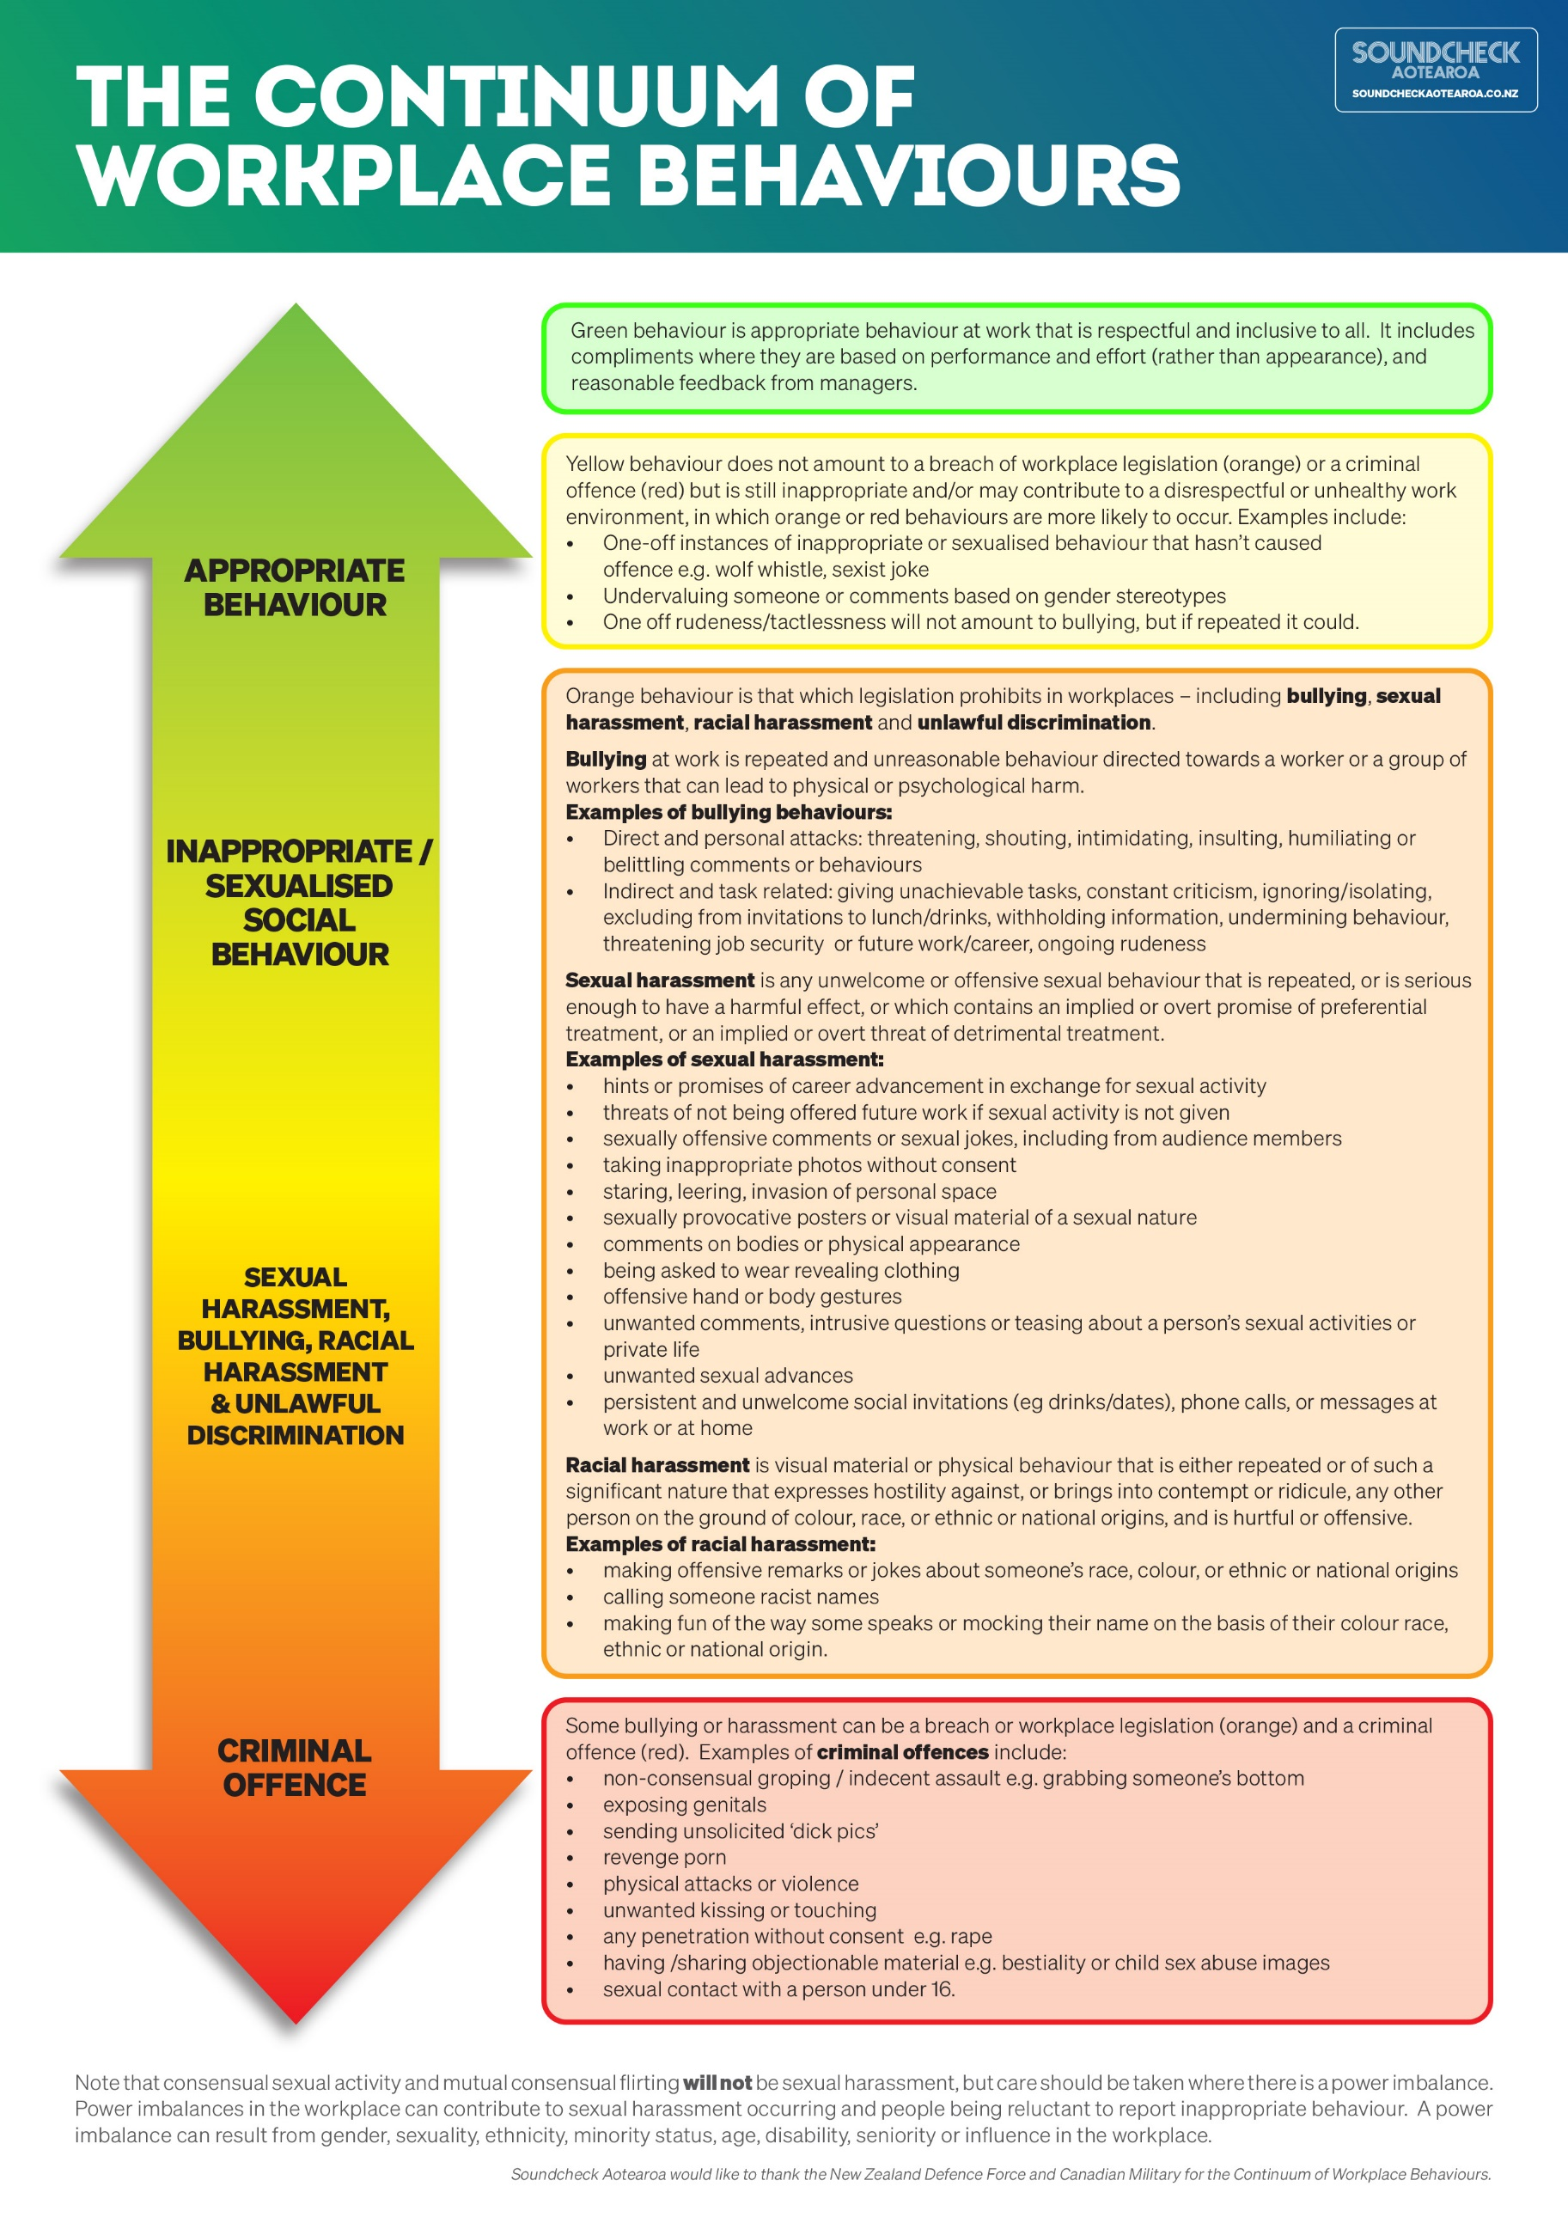

See Sexual Harm and Consent section of SoundCheck Aotearoa website for more information on criminal offences.
The age of consent in New Zealand for sexual activity is 16 years.

