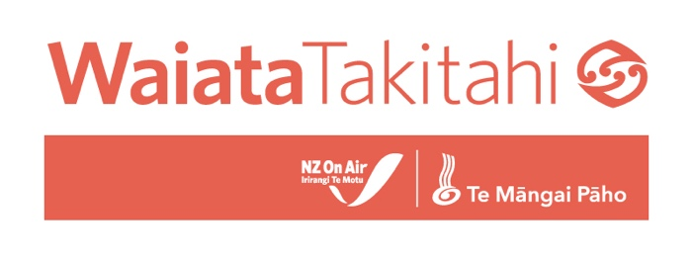

GUIDELINES FOR SAFE SPACES

When heading into a session, video shoot, or collaborative space with people you don’t always know, it’s important to have some common ground rules for a really positive and safe environment- it always leads to the best experience, and the best outcomes!
This resource is useful for artists, videographers, photographers, producers, and any collaborators to have security and confidence in entering collaborative situations. Respect and safety are our priority for all of NZ On Air’s funding schemes.

DISCLAIMER:
This document is not legally binding and is intended as a guide only to create a safe environment for creative activity. It does not anticipate every situation that might occur but the goal is to ensure the safety, respect, comfort and accountability of all participants in all meetings and collaborative environments within the music industry.
This resource is an acknowledgement that there are systemic and harmful power imbalances within the music industry, and a commitment to help create change. I acknowledge specifically that those issues often relate to gender, sexuality, ethnicity, minority status, age and ability.

With regards to all our future sessions and communications;

- I commit to upholding Tīkanga Māori and Māori values by demonstrating and/or following protocols as is appropriate.
- I will follow and/or establish guidelines where needed with respect to ethnicity or cultural protocols.
- I commit to being aware of issues relating to gender, sexuality, ethnicity, minority status, age and ability in the music industry and working to actively create a professional, comfortable and safe environment free from discrimination, harassment or abuse.
- I will not place unnecessary attention on, or discriminate based on a person’s gender, race, ability, age, sexuality, career status or on any other personal or cultural attribute.
- I will respect physical boundaries and space at all times
- I will ensure I have a parent or guardian as chaperone for any and all commercial dealings with minors.
- I will conduct any communication or engagement, both prior and post our meetings, in a professional, respectful and confidential manner.
- I will support the agency and autonomy of all to self-determine their own futures, including trans and gender diverse people and will challenge homophobia and transphobia when I see it.
- If unsure, I will offer my own pronouns (he/she/they/etc) when introducing myself, before asking how others identify themselves.
- I acknowledge I have a duty of care in reporting or raising any incidents should they arise, upholding confidentiality and taking into consideration the safety and mental wellbeing of all parties in discussing such incidents.

If you feel any concern in regard to any of the points above please do not hesitate to reach out to the team at NZ On Air or Te Māngai Pāho to discuss confidentially.
Ash Wallace: ash@nzonair.govt.nz
Nadia Marsh: Nadia@tmp.govt.nz

Director name: _________________________  Signature: _____________________________  Date: _________________________________ | Artist name: ___________________________  Signature: _____________________________  Date: _________________________________

